Sugar, Spice, and Everything Geist!
Tagline: N/A
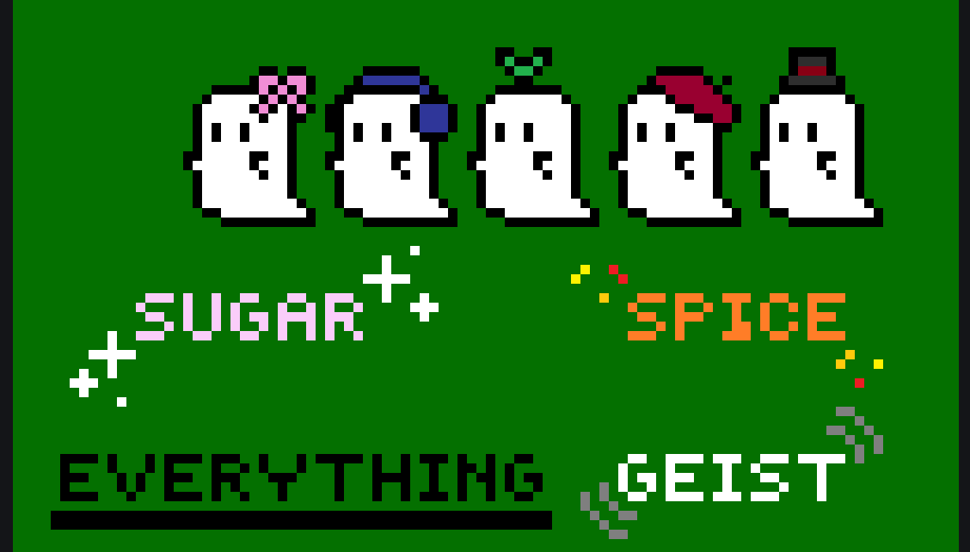
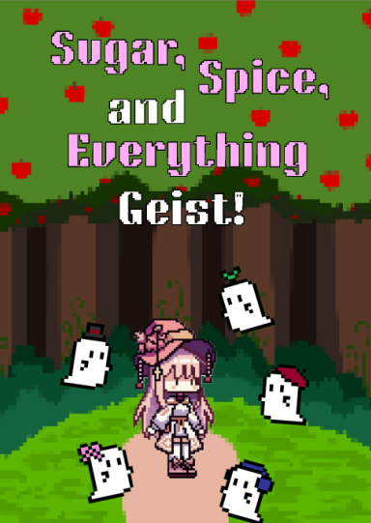
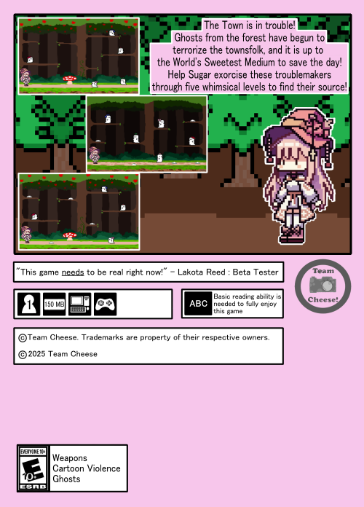
Contents
Game Overview: 3
Gameplay: 4
Mechanics: 5
Story and Narrative: 6
Game World: 7
Characters: 9
Sugar (Main Character) – 9
Ghosts- 10
Medium – 12
Levels: 13
Interface: 20
Game Art: 21
Game Marketing Plan - 22
SWOT Analysis 25
Game Design Pillars 27

Game Overview:
Concept: Cutesy platformer where you fight ghosts to “save” the town
Target Audience: Teens, Young Adult (Rating E 10+)
Genre: 2D Platformer
Game Flow Summary: Player collects salt in the level, then uses it to beat enemies, once all enemies are beaten, a boss door unlocks and the player fights the boss.
Look and Feel: Pixel styles, cutesy saccharine graphics.

Pitch: The town is in trouble! Ghosts from the forest have begun to terrorize the townsfolk, and it is up to the World’s Sweetest Medium to save the day! Help Sugar exorcise these troublemakers through five whimsical levels to find their source!

Gameplay:
Objectives: Defeat all ghosts in a level to fight the boss and progress.
Game Progression: 5 levels, each ending in a boss.
Play Flow: Collect salt, damage enemies.
Mission Structure: Linear
Puzzle Structure: N/A

Mechanics:
Rules: Player must collect salt to damage enemies, Salt is only used up if it is used to kill an enemy. Blade is used to break obstacles.
Physics: 2D, gravity
Economy: N/A
Character Movement in the Game: Two directions, jump upwards. Fall down through platforms
Objects: Blade, Salt.
Actions: Throw Salt (Hold to throw farther). Use Blade. Jump. Fall Through.
Combat: Salt kills any regular enemy in one hit, if they are hit with it. 3 hits for bosses
Screen Flow: ???
Game Options: N/A
Replaying and Saving: Game can be replayed, only 1 save slot, player must reset to start a new playthrough.
Cheats and Easter Eggs: TBD

Story and Narrative:
Backstory: Town hires a medium to investigate and deal with ghosts in the woods
Plot Elements: Medium is in town, goes to investigate the woods.
Game Story Progression: Very Static Story
Cut Scenes: Boss defeat cutscenes

Game World:
General Feel of the World: Cutesy and Sweet
Areas: Woods
General Description and Physical Characteristics: Very cutely drawn style
How They Relate:
What levels use it: First, gets less cute as game progresses
Connections to other areas: Game slowly loses this style and adopts an otherworldly, mysterious and dark style.
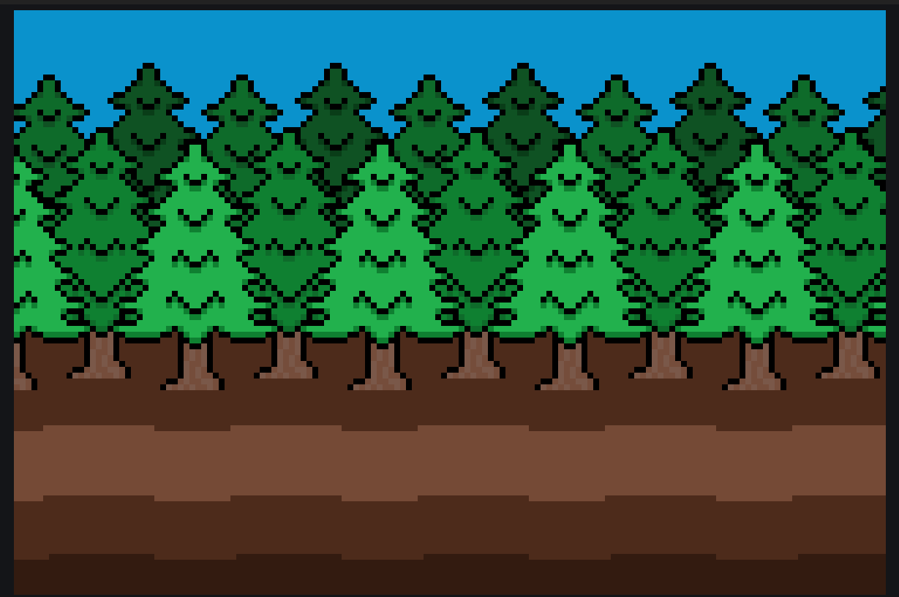
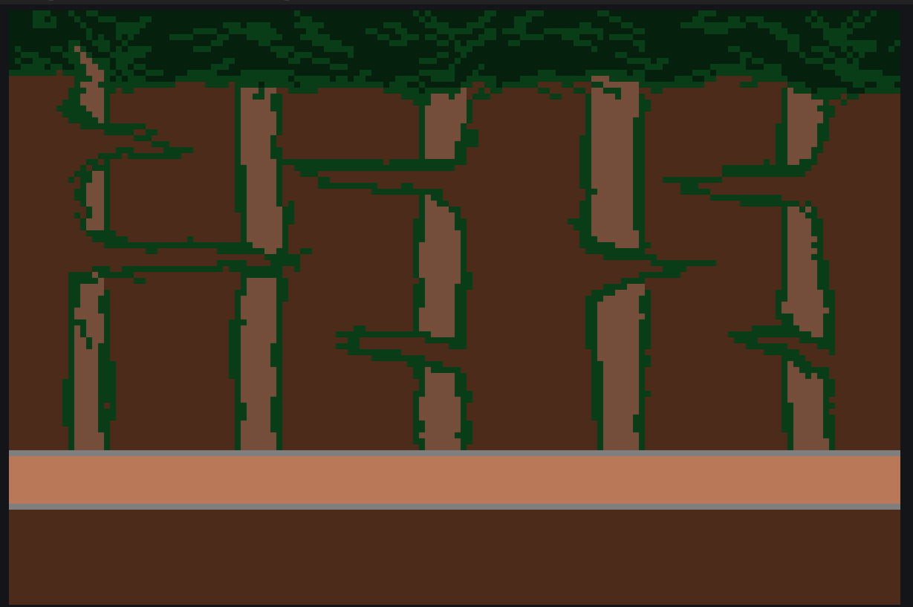
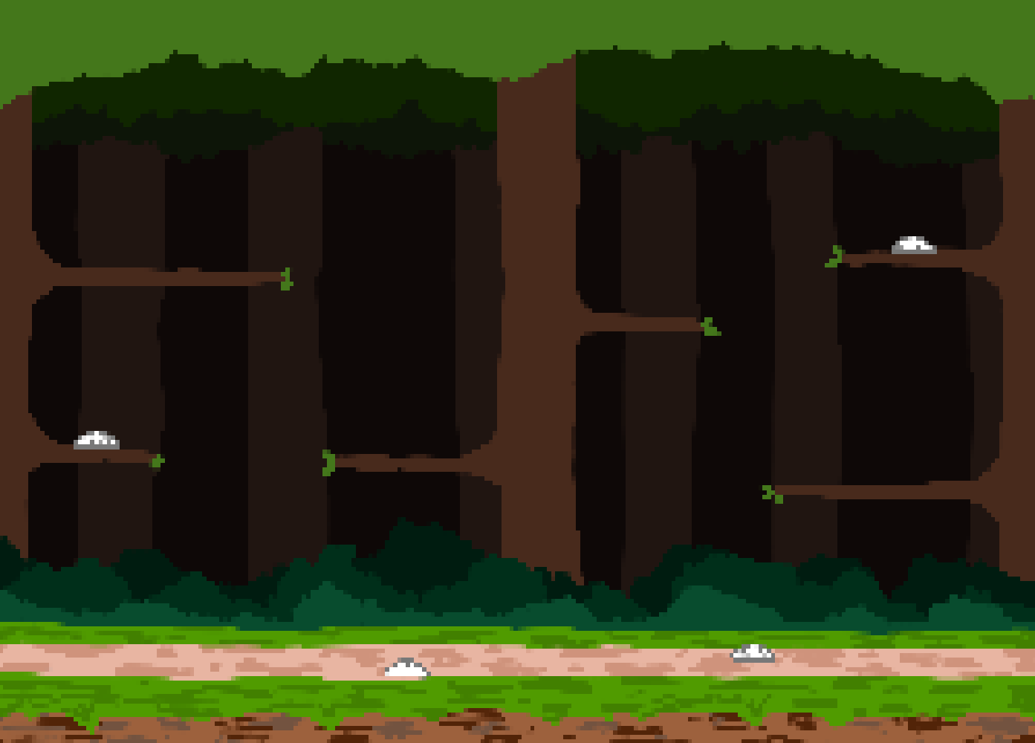

Characters:

Sugar (Main Character) –
Backstory: A murderer, who has been killing victims in the woods in a small town
Personality: unapologetic for the things they’ve done, manipulative
Appearance: A normal, unassuming person
Abilities: Skilled with both the machete and salt.
Relevance to the story: Main Character
Relationship to Other Characters: Caused the Ghosts, tricking the Medium into helping clean up all the evidence




Ghosts-
Backstory: Ghosts created by the Main Character
Personality: Vengeful
Appearance:
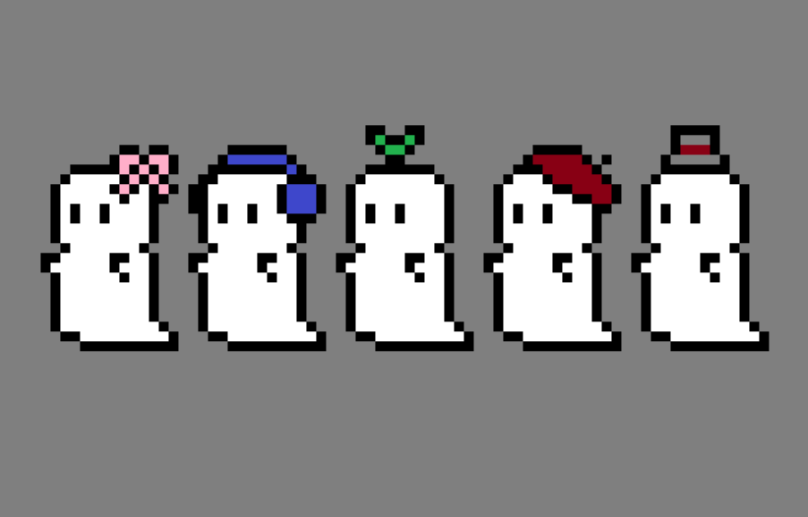
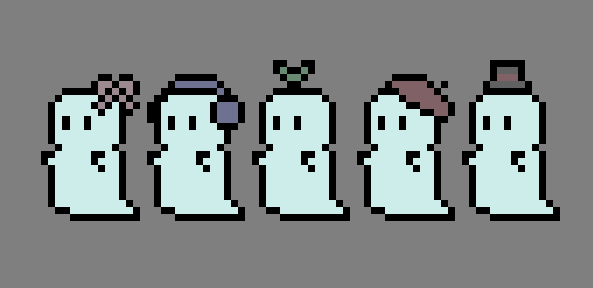

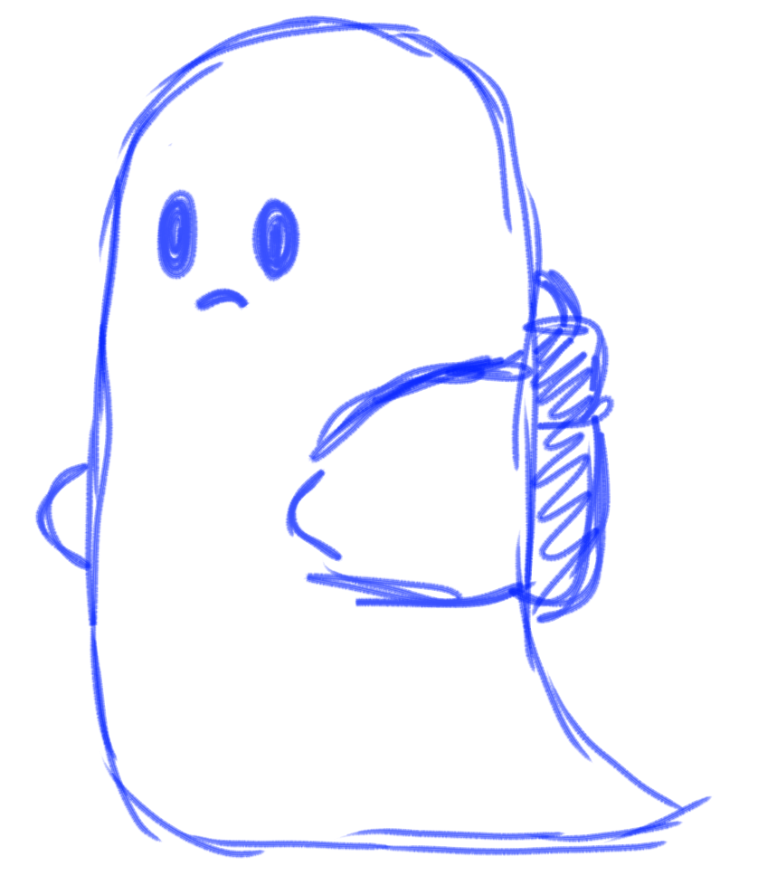
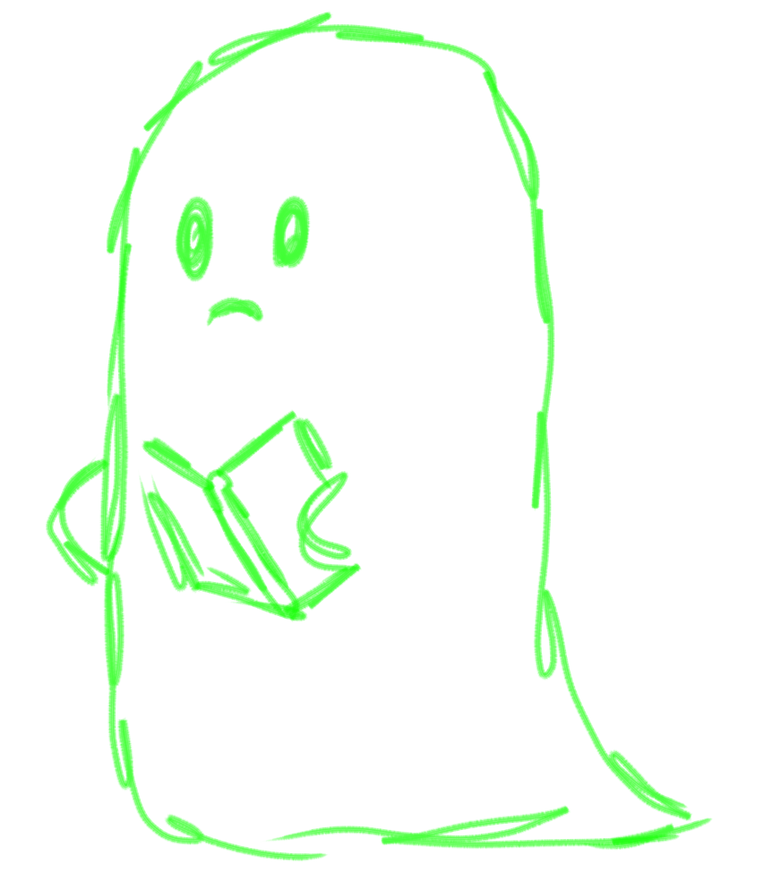
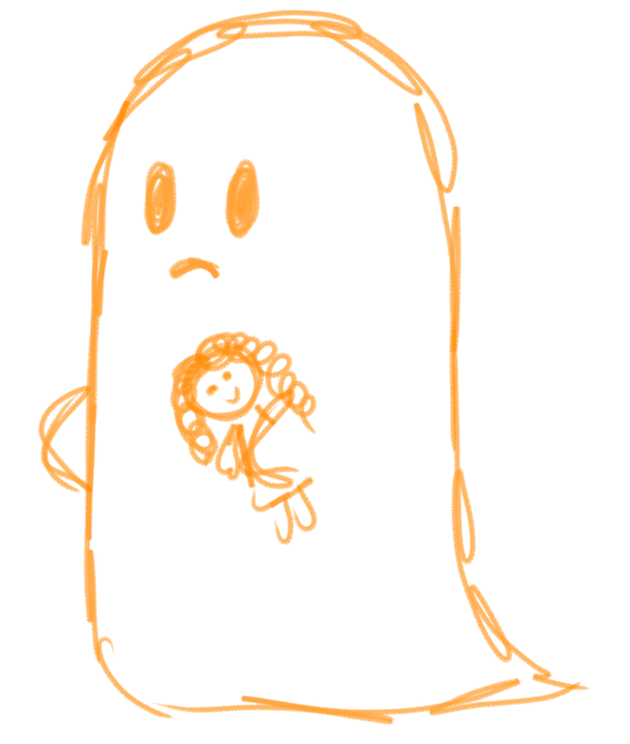


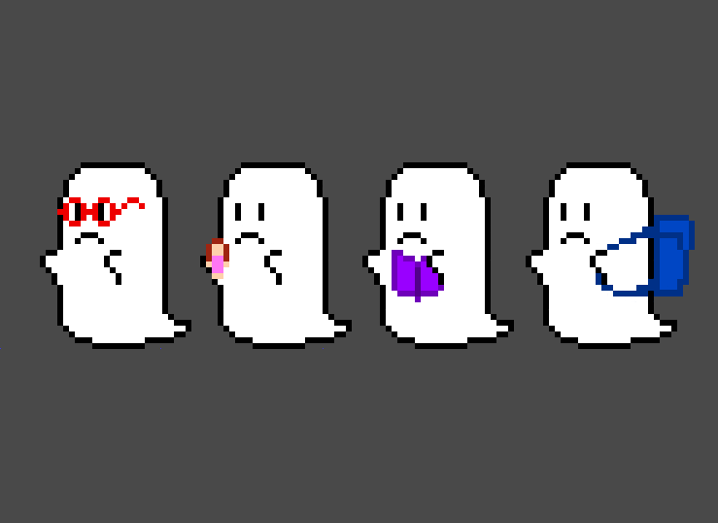

Abilities: Possession, immunity to all non-salt hostilities, General Ghost abilities
Relevance to the story: Main Character
Relationship to Other Characters: Looking to warn the Medium to what the Main Character is up too

Medium –
Backstory: One of the world’s best mediums, invited to a small town in order to clean up the ghost problem.
Personality: Gullible
Appearance: N/A
Abilities: Can see ghosts, Helps direct the Main Character
Relevance to the story: The actual player of the game themselves
Relationship to Other Characters: Being tricked by the Main Character, The Ghosts are trying to warn them
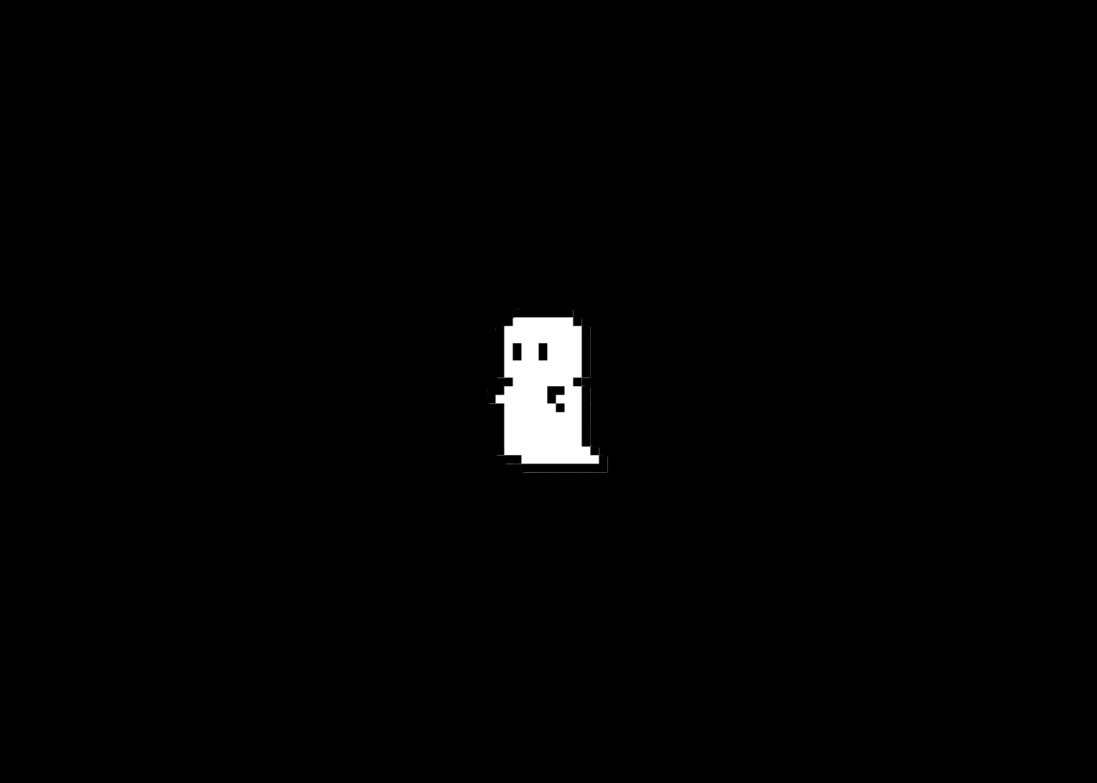
Pic: Only one available- End of Game

Levels:
Training Level: 1st level, no real tutorial. – Soft tutorial, ease player in. give players all mechanics, similar to 1st level in Mario
For Each Level -
Synopsis: Woods
Introductory Material: N/A
Objectives: Defeat all Ghosts
Details:
1-2 regular enemies
3-4 Faster Enemies
5 Fastest Enemies
Enemies get mixed in.
MAP: TBD
Critical Path: TBD
Important and Incidental Encounters: Boss room at the far end, only opens once all enemies are defeated.
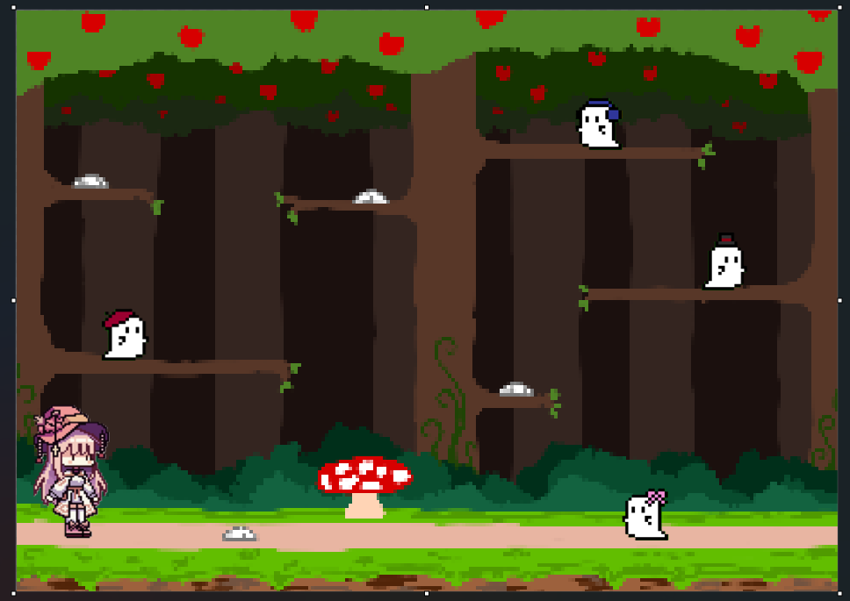
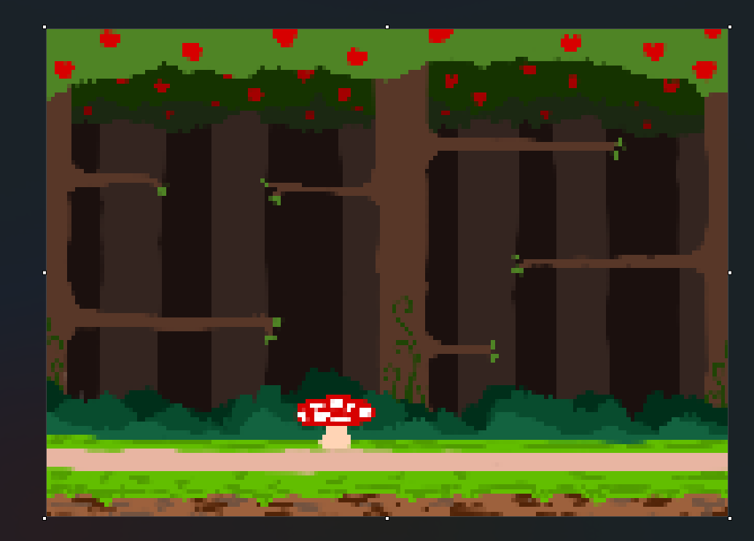
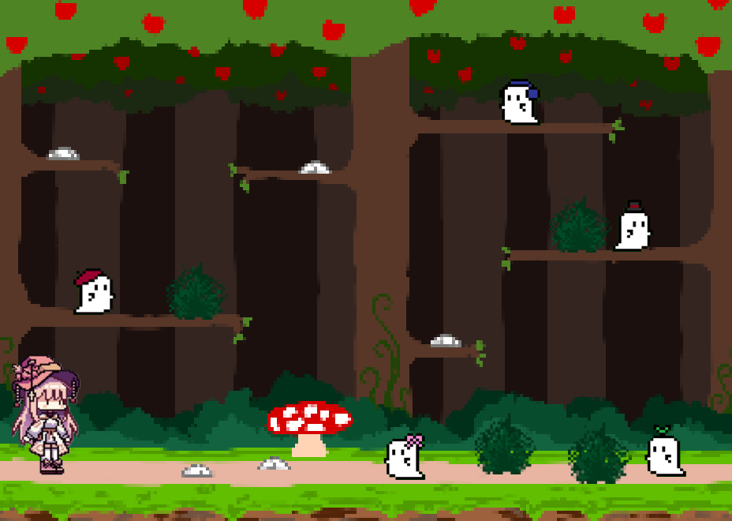
With added Bushes:

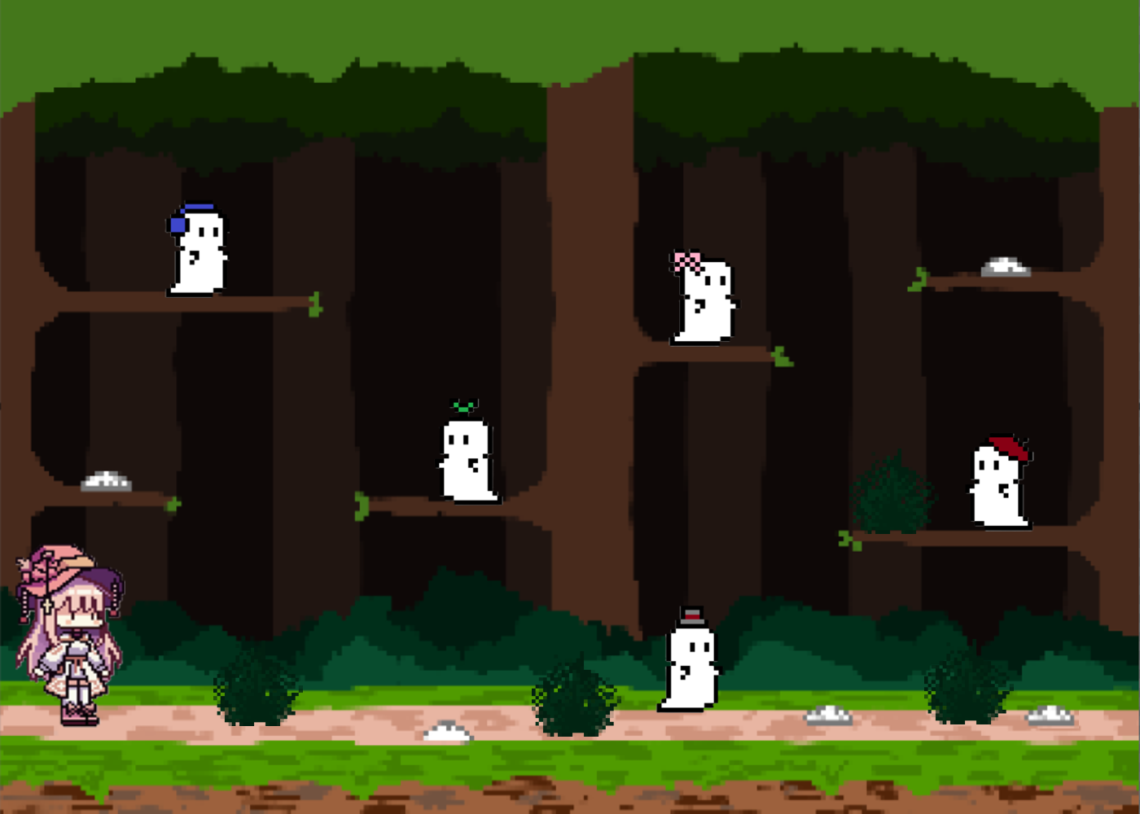

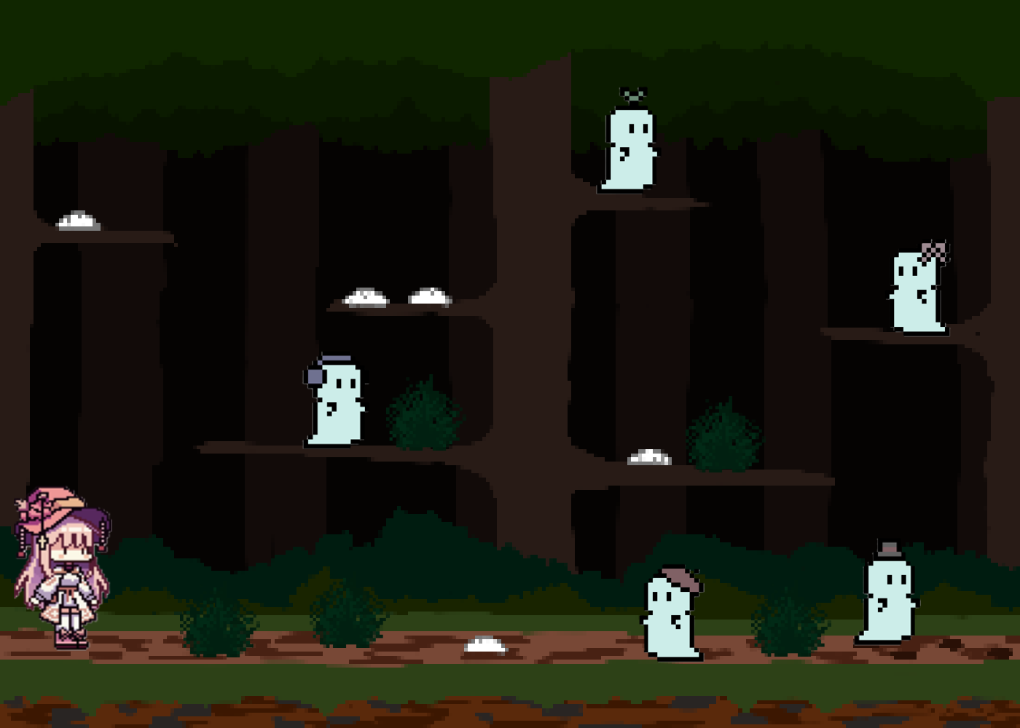

Boss Levels:
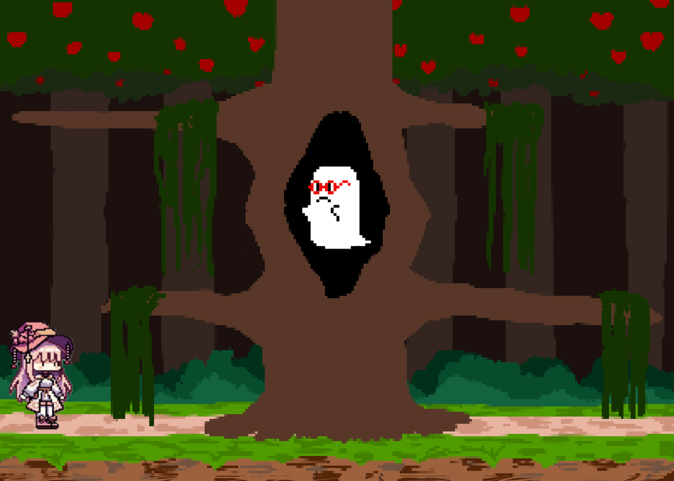
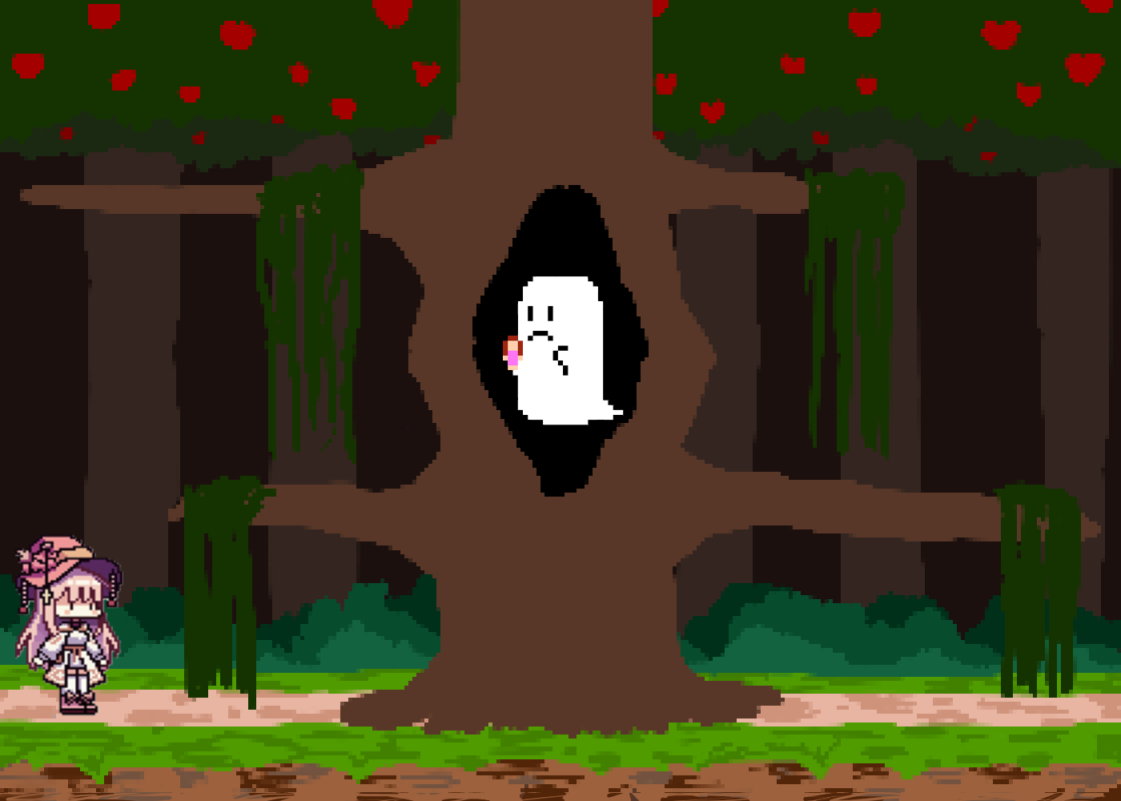
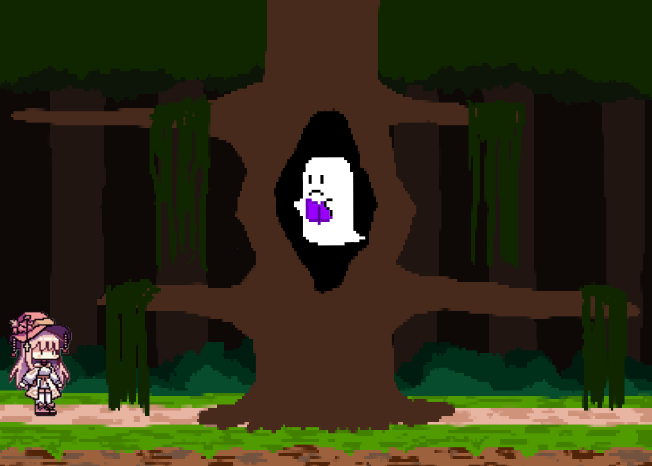
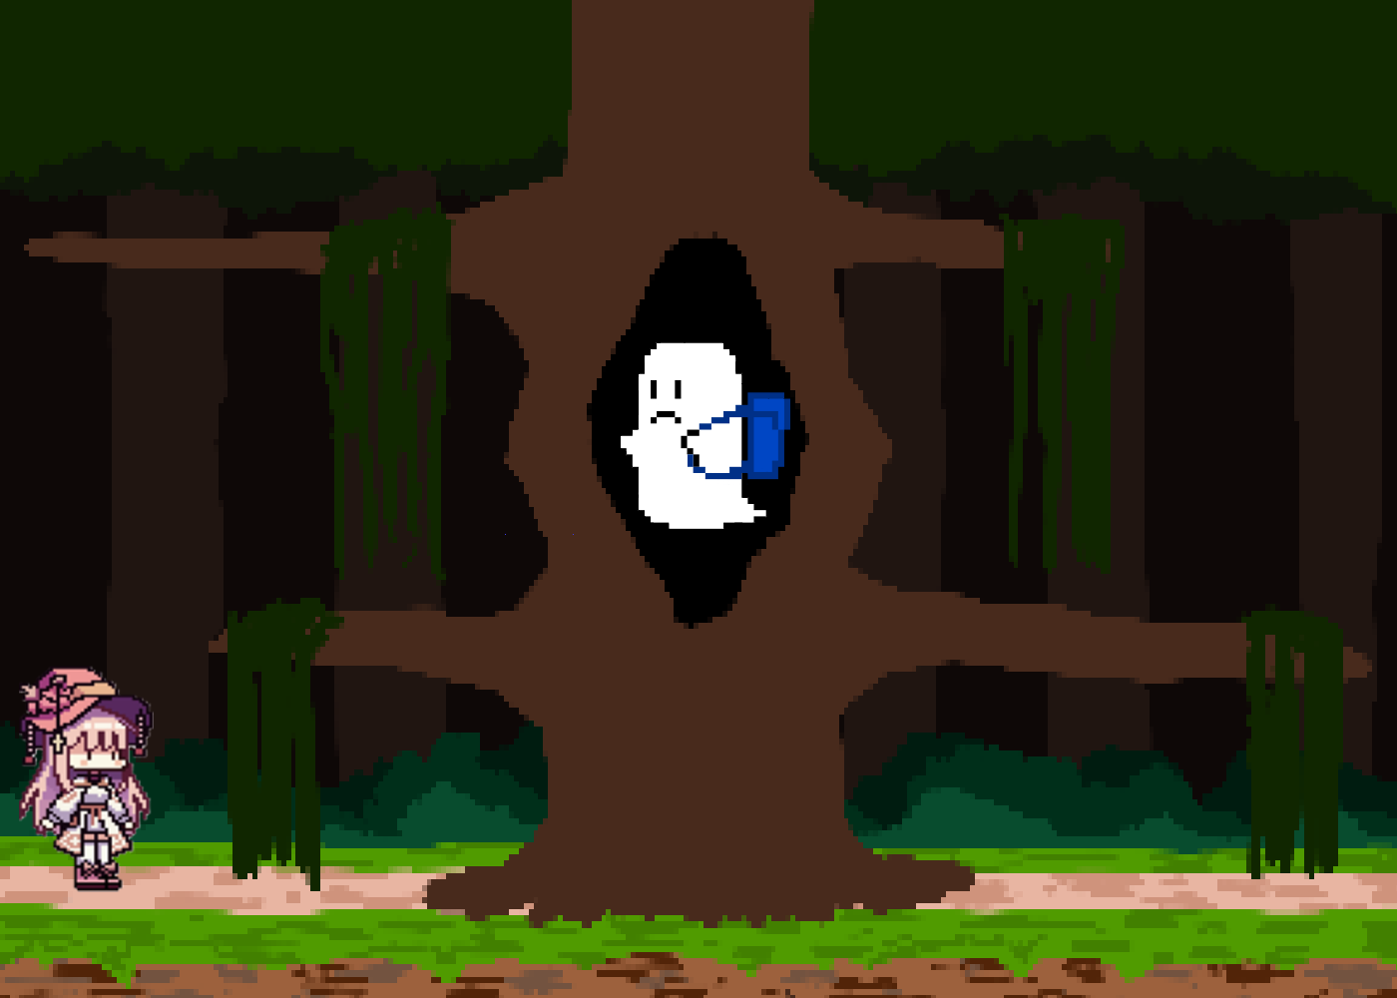
Final “Boss Fight” Arena:
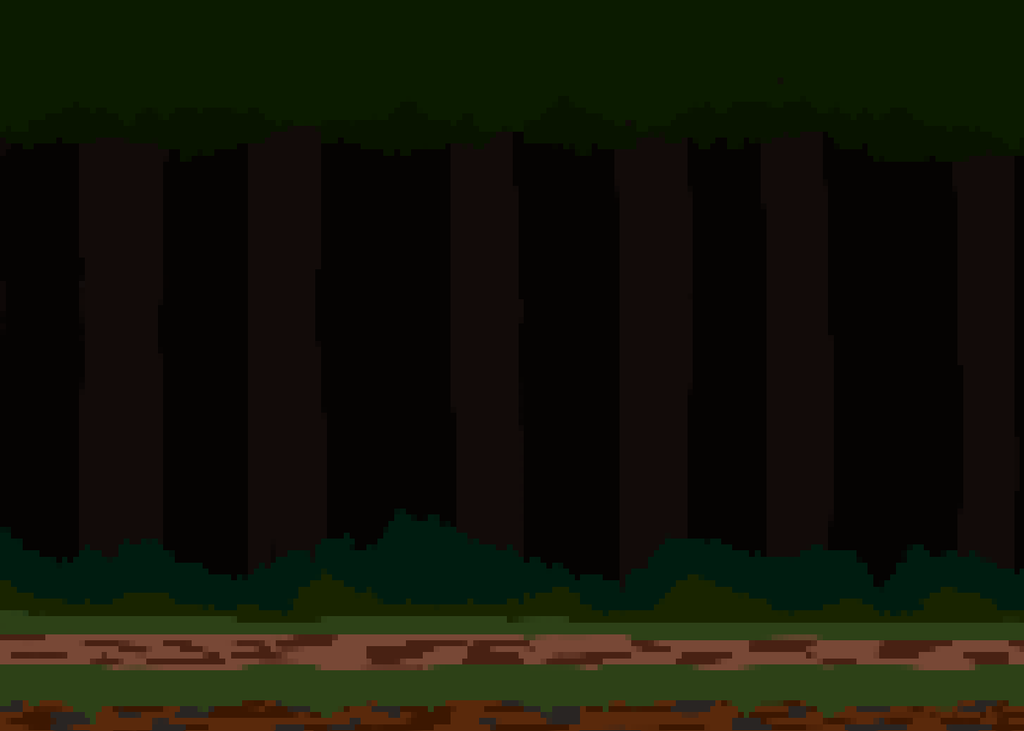
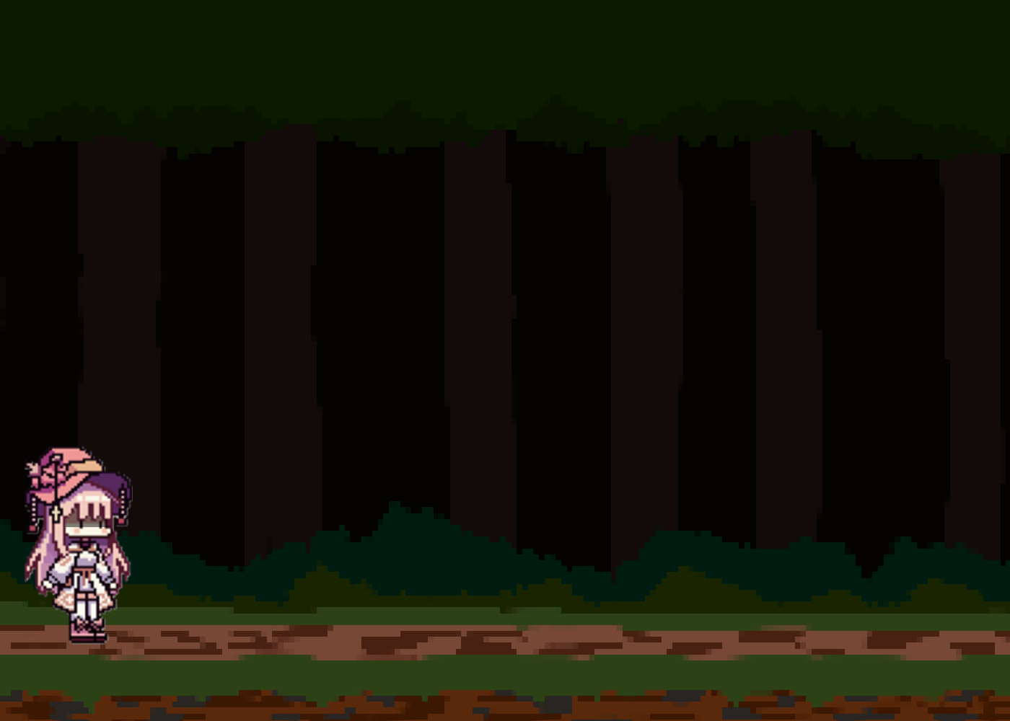
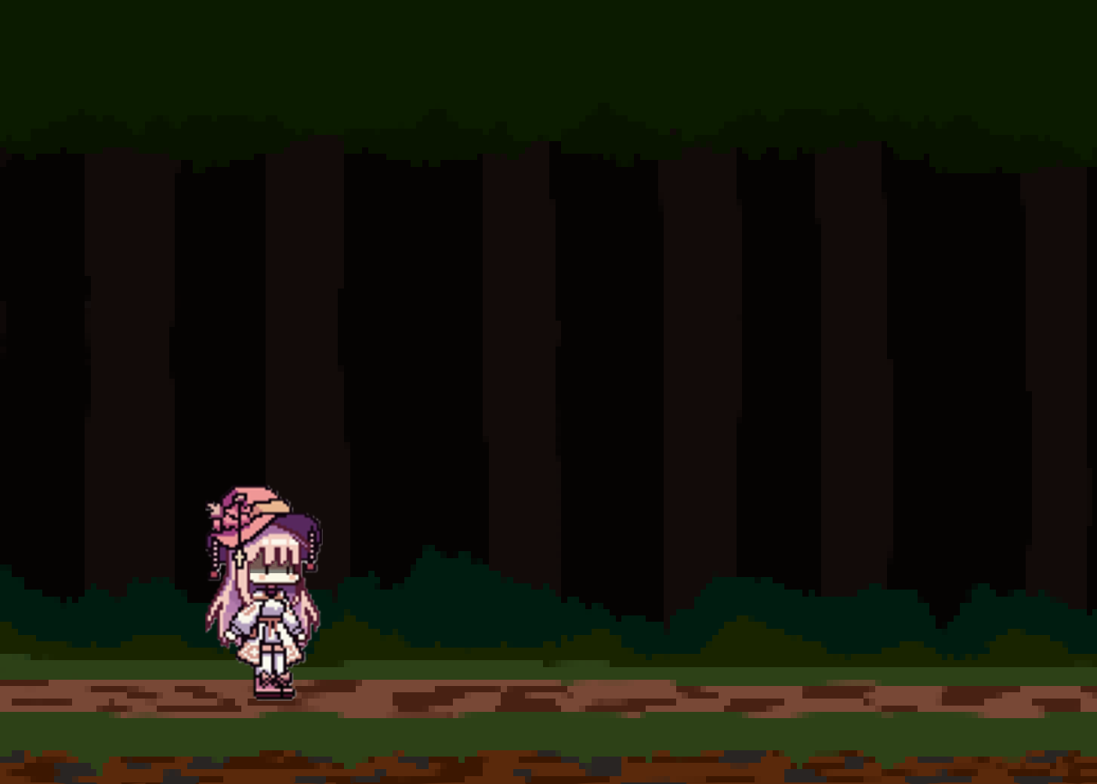
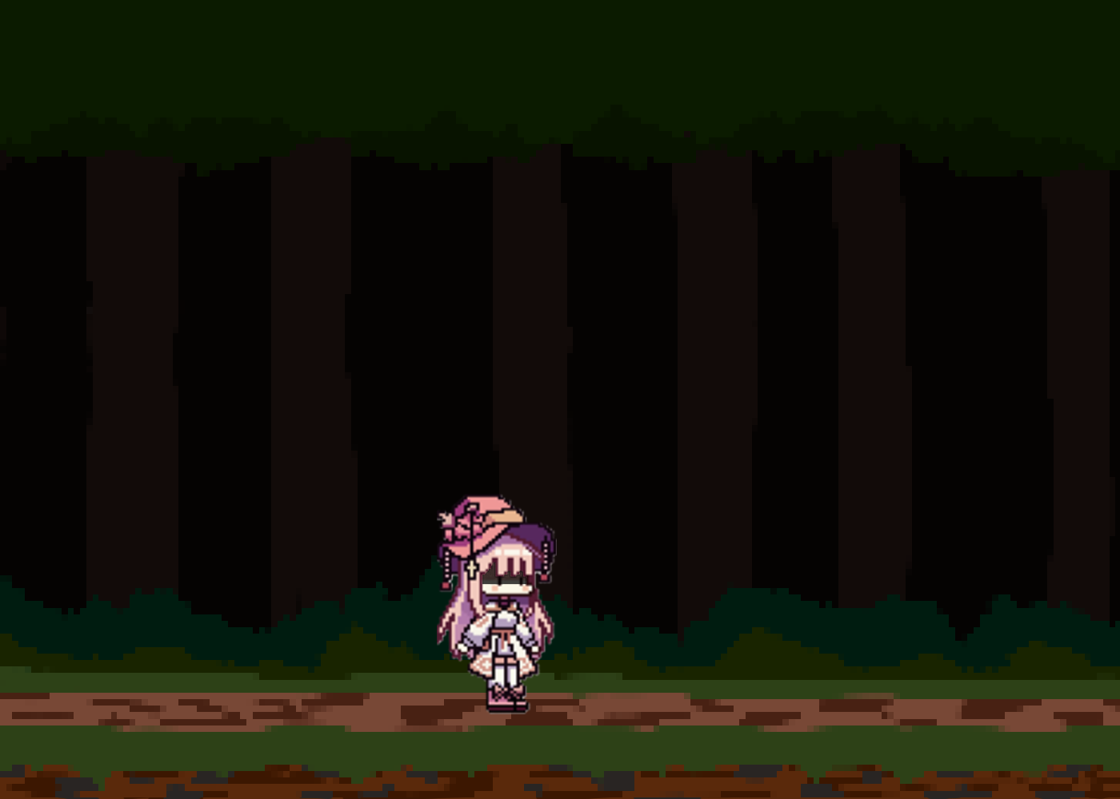

Interface:
HUD: Salt Counter on the bottom of the screen. Heart shaped bar in the top left that displays the players current life (3 Maximum) shards will disappear as the health ticks down. UI for the rest of the game should stay blocky and light, pink will be the main color, and selection indicators for what setting is chosen are small hearts.

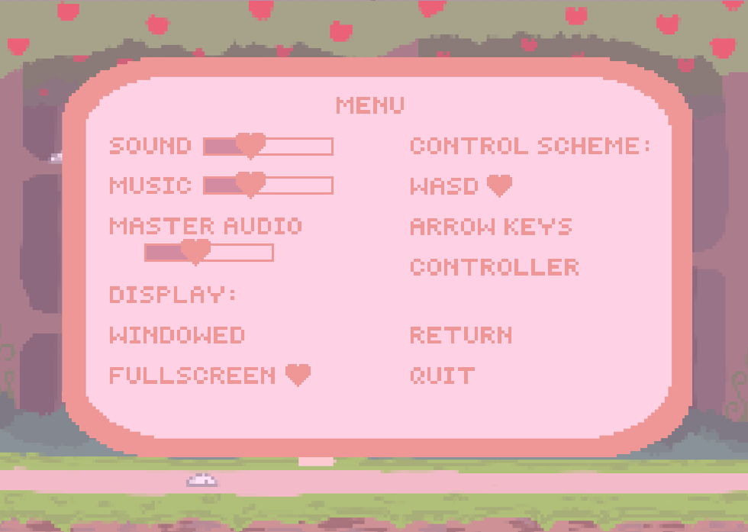
Menus:
Camera model: 2D Sidescrolling
Control System: Keyboard and Mouse, Controller
Audio, Music, Sound Effects:
Chippy, 8-bit tune playing through the game. Slowly breaking down as the game continues in levels. The final level is completely silent, with no music playing.
Sound effects when a ghost is killed/hit, upon jumping, obstacle breaking.
Sound Effects: Ghosts have voice lines talking to the player

Game Art:
Intended Style: Kirby-like, cutesy. Entirely pixelated.

Game Marketing Plan -
1. Game Overview
- Title: Sugar, Spice, and Everything Geist
- Genre: Side scrolling 2D platformer
- Platform(s): PC and consoles
- Target Audience: Teens and young adults
- Unique Selling Points (USP): Style and Story
2. Market Research
- Competitive Analysis:
  - Key competitors – Doki Doki Literature Club, Fran Bow
  - Strengths & weaknesses of competitors – Famous but old news, Famous and is having a come back
  - Opportunities for differentiation – Style and mechanics
- Industry Trends:
  - Emerging technologies – N/A
  - Player preferences and market shifts – Easily accessible and free
- Player Personas:
  - Who is your ideal player? – Curious and innocent individual
  - What motivates them to play your game? – The story
3. Branding & Messaging
- Game Logo & Visual Identity – cutesy pixel art
- Tagline/Slogan – N/A
- Key Themes & Emotional Appeal – Fun and mystery
- Brand Voice & Tone – Energetic and innocent
4. Marketing Strategy
Pre-Launch
- Teaser Trailers & Announcements – Cute and vague
- Social Media Presence (Twitter, TikTok, Instagram, etc.) - Player’s experience
- Website & Landing Page - N/A
- Press & Influencer Outreach – N/A
- Community Engagement (Discord, Reddit, forums) – Indie dev forms
- Crowdfunding or Early Access Plans – N/A
Launch
- Game Launch Trailer – Cute but vague
- Press Releases & Media Coverage – N/A
- Influencer & Streamer Partnerships – N/A
- Paid Advertising (Google Ads, Meta Ads, YouTube, etc.) – N/A
- Giveaways & Contests – N/A
Post-Launch & Ongoing Engagement
- Live Events & Tournaments N/A
- User-Generated Content (Mods, Art, Streams) – Hopefully?
- DLCs & Updates – N/A
- Retention Strategies (Loyalty programs, exclusive content, etc.) – N/A
5. Monetization Strategy
- Pricing Model: [Premium, Free-to-Play, Subscription, etc.] - Free
- In-Game Purchases & Microtransactions – N/A
- Partnerships & Sponsorships – N/A
- Merchandising Opportunities – Depends on how game performs?
Key Performance Indicators (KPIs):
6. Metrics & Performance Tracking
  - Sales & Revenue – Steam or Itch.io but no revenue
  - Player Retention Rate – low due to plot
  - Engagement Metrics (social media, forums, streams) - digital marketplace forms
  - Reviews & Feedback – Steam and or Itch.io rating systems
- Tools for Tracking:
  - Google Analytics – N/A
  - Steam Spy, App Store analytics – yes?
  - Social Media Insights – yes?
7. Timeline & Budget
- Marketing Phases & Deadlines – Dec 17th (teehee)
- Budget Allocation for Ads, PR, Influencers, etc. - $0 dollars bay-bee
- Contingency Plans & Risk Management – “Let’s go gambling!”
8. Conclusion
- Summary of Key Strategies – Hope for the best, tis the life of an indie dev

SWOT Analysis
Team name: Team Cheese
Team members: Hannah, Isabel, Austin, Dazhon
Instructions
Fill out each section with your game's specific details. Be honest and thorough in your assessment to get the most value from this analysis.

Strengths
What advantages does your game have? What do you do better than anyone else?
- Fun Plot Twist >:)
- Cutesy art style and Visuals
- Engaging Puzzles
Weaknesses
What could you improve? What should you avoid? What might players criticize?
- Simplistic Gameplay

Opportunities
What interesting trends are you aware of? How can you turn your strengths into opportunities?
- Cutesy to Scary was popular
- Platforms are easy to get into

Threats
What obstacles do you face? What are your competitors doing? Are quality standards or specifications for your game changing?
- Hard to recommend the game without spoiling
- Genre of cute to scary was bloated in a short span

Reflection Questions
- How can you use your strengths to take advantage of the opportunities you identified?
Cutesy style invites players into the friendly platformer.

- How can you overcome the weaknesses that prevent you from taking advantage of these opportunities?
The story and twist should keep players interested in the game.

- How can you use your strengths to reduce the likelihood and impact of the threats?
Our take on the twist should keep people engaged.

- What plan can you create to address your weaknesses and minimize potential
threats?
Adding new mechanics to keep game-play from becoming repetitive.

Game Design Pillars

Pillar | Definition | Example | Your Game Concept
Plot | The actual storyline of the game, stripped down to what happens. | Bioshock’s twist ending | Medium gets called into town to solve the ghost problem in the woods.
Character | The aspect that fleshes out characters, giving them personality and making them relatable. | Kratos’ relationship with his son in God of War (2028) | The player assumes the role of the medium allowing them to see the ghosts on screen. This allows them to direct the “main character” the murderer who has caused the ghost problem. Despite controlling him, the player is not the main character.
Lore | Everything that makes the game world feel vibrant and alive, existing beyond the main characters and plot. | The item descriptions in Dark Souls | A murderer in a town has been luring people into the forest and killing them, they’ve now risen as ghosts inhabiting the woods.

Instructions:
- For each pillar, describe how it will be implemented in your game concept.
a. Plot would be implemented via exposition.
b. Character would be implemented via game-progression.
c. Lore would be implemented via dialog and cutscenes.

- Identify which pillar(s) will be the primary focus of your game.
a. Plot would be the primary focus.

- Explain how the other pillars will support the main focus, even if not central to the game.
a. Character supports the Plot by playing the game and discovering the ending.
b. Lore supports the Plot by interacting with dialog.

- Consider how game mechanics, visuals, and level design can reinforce each pillar.
a. The opening-exposition supports the Plot.
b. The game-level-progression supports the Character.
c. The combat system supports the Lore.

