PaintRush!
“What’s your color?”

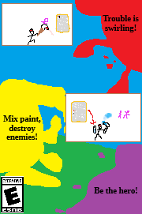
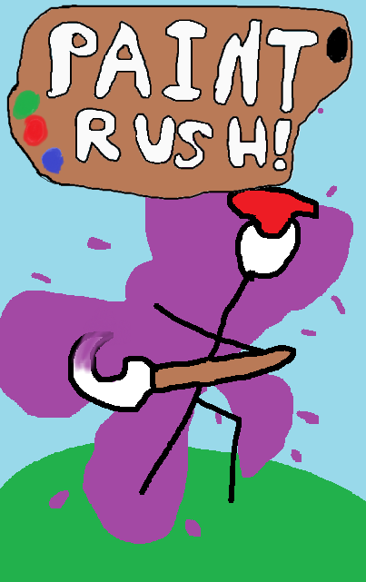
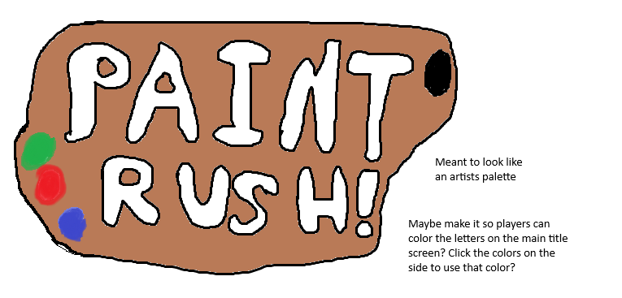
Contents
Game Overview: 4
Gameplay: 5
Mechanics: 6
Story and Narrative: 8
Game World: 9
Characters: 10
Prima (Main Character) – 10
Tetra (Main Antagonist) – 10
Levels: 12
Interface: 13
Elevator Pitch: 15
Game Design Pillars: 16
Marketing Plan: 17
SWOT Analysis: 19

Game Overview:
Concept: A game about mixing your own color to help create your gameplay.
Target Audience: Young Adult and up. Might be a little difficult for young children. (Ultimately Rated E for Everyone)
Genre: Action, Adventure, Roguelike
Game Flow Summary: Player defeats enemies to get dropped items to gain power to beat more enemies, making the core loop of the game.
Look and Feel: A very “drawn” look to the game, it’s meant to represent traditional styles of art.

Gameplay:
Objectives: Players must defeat bosses to proceed through the story.
Game Progression: Players must beat their way through 5 dungeons, each ending with a boss. Players must beat all levels sequentially with only 1 life, upon death the player restarts from the beginning, losing all items and progress.
Play Flow: Players fight groups of enemies in rooms within the dungeons, picking up dropped loot upon defeat. After defeating all enemies in one room, the player is able to progress into the next room.
Mission Structure: There will be 5 dungeons, ramping in difficulty. Dungeons are procedurally generated.
Puzzle Structure: N/A

Mechanics:
Rules: All enemies must be defeated. One life per “attempt”, if you die you restart from the very beginning, losing all progress.
Physics:
Economy: Shops are available to help buy items, one shop is generated per dungeon, enemies drop coins.
Character Movement in the Game: The game is angled top down, the player can move in all 4 directions freely.
Objects: Press an interact button to pick up and equip items. No other objects move. (Although some rooms might contain breakables.)
Actions: One “interact” button is used for actions, opening doors, picking up items, and talking to NPCs. There are also buttons to add or subtract dropped colors from the players color. Besides this the player can melee attack, and has a ranged attack they need to build up.
Combat: A main feature of the game, the player must clear a room full of enemies before they may progress. Hack and Slash style. Enemies have a set amount of health that must be taken before they die.
Screen Flow:
Game Options: The main option comes in the player’s Color Mixture system, allowing the player to choose what skills and effects they are good at.
Replaying and Saving: You may rejoin a “run” in progress if you leave it. Or you may start over. Once the game is beaten it can still be replayed, likely with optional challenge modes.
Cheats and Easter Eggs: N/A
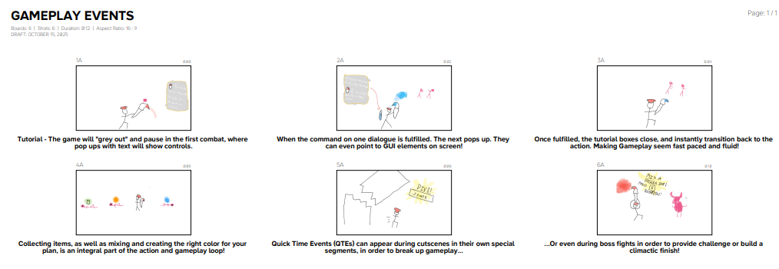

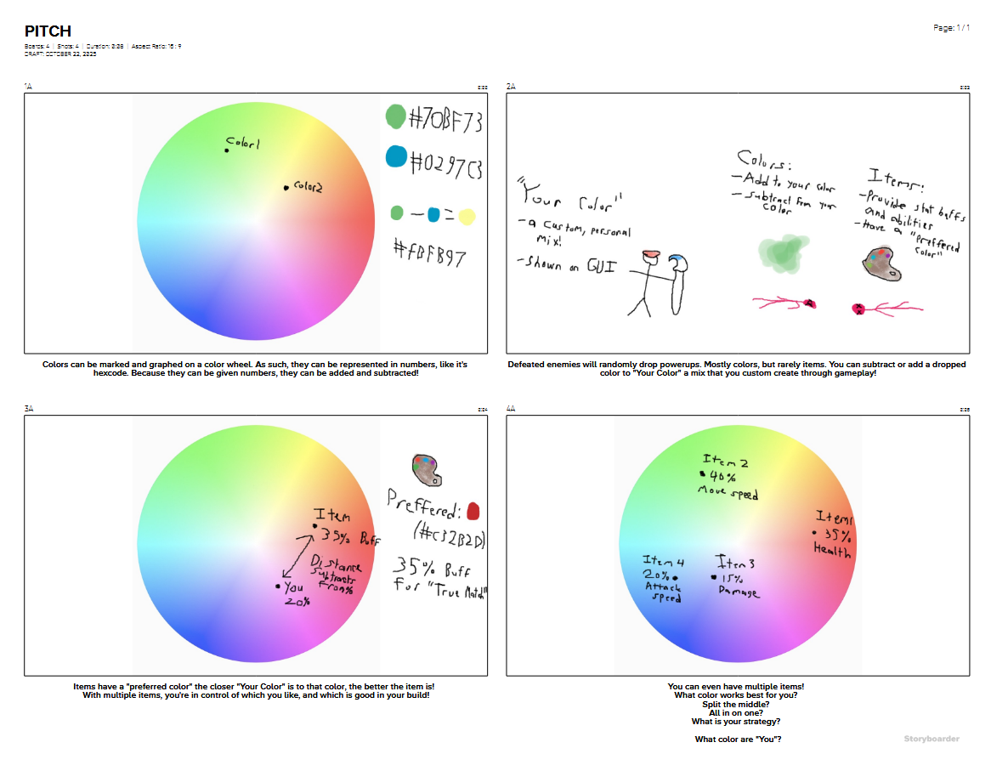

Story and Narrative:
Backstory: Long ago, colors ran rampant, causing havoc for the people around. As such, they were labelled “forbidden” and sealed away. Leaving a world only in black and white. Only painters were allowed to use and create with color, lesser ones than the specific forbidden colors.
Plot Elements: Someone is trying to unleash the sealed away colors, and it is up to the player to stop them.
Game Story Progression: The game progresses with the antagonist unsealing these colors at the end of each dungeon, and the player having to fight them to reseal them back in.
Cut Scenes: Non-Animated, quick bits of dialogue between the main character and the antagonist at the start of each dungeon, at the end of each dungeon, and right before a boss fight.

Grand Storyline: (From Document)
“-Not specifically nations at war. If anything, it’s more a united nation vs an overwhelming threat.
-The history of the nation and this conflict is connected to the big event that shook up the world previously.
-There was a war long ago, and the losing side was sealed away. The current story is the undoing of those seals, meaning it is a direct result and after effect of that event.
-The hero’s role is that of an actual hero. They are expected to deal with the threat by the general population. The citizens of the world respect and believe in the hero. The hero is regarded as special compared to the average person.
-An unknown revealed along the way is that of the villain’s motivations. She is going to be actively working against the hero through the story. With a very rough around the edges character. However, she just has a very different outlook on the world compared to the hero. She wants to believe in the wild things she’s releasing, despite the bad they might cause. She finds sympathy for the enemy. She is ultimately meant to work along a theme of “Don’t judge a book by it’s cover”. But she isn’t meant to be entirely good or “the actual hero” by any means. Although her intentions are good, her actions have terrible consequences. (Until hopefully the hero can help her out). She knows she is doing something bad, but goes through with it any way.
-The main clashing is between the main character and the villain. As this is a game with a very linear story. They are each the main faces of their respective sides in the story. And as such, their interactions are the ones that carry the most weight. There are not any other factions of importance to cause this to be a multiple sided incident. It’s meant to be very simple and easy to follow in its story.”

Game World:
General Feel of the World: Dreary, with no color around and crawling through dungeons making the world feel bleak. But also the white and black sketch style giving the feeling of hope and creativity. The player leaving drops of color helps change and break up the atmosphere.
Areas: Each dungeon is different, each with it’s own themes and mechanics.
General Description and Physical Characteristics: TBD
How They Relate: These are literal dungeons, jails of great evils dealt with long ago.
What levels use it: All of the combat levels follow this theming.
Connections to other areas: possibly a town to start in? The dungeons and levels are far off and remote from anything, isolated.
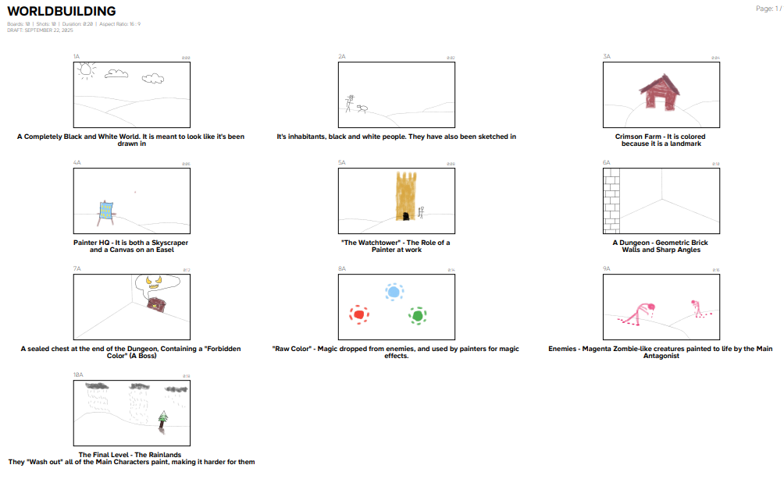

Characters:

Prima (Main Character) –
Backstory: A newly established painter
Personality: plucky and looking to do good. New to things so the players can relate to her better. Unsure of herself after having been given such heavy responsibility.
Appearance: Carries a large paintbrush that she uses as a weapon. Wears a bright red heat to differentiate herself from all the uncolored surroundings.
Abilities: As a painter, she has the ability to mix and utilize color, which augments her and helps her in her quest for good.
Relevance to the story: Main Character
Relationship to Other Characters: Against the main antagonist, they have a difference in views, and she believes she must put a stop to her.
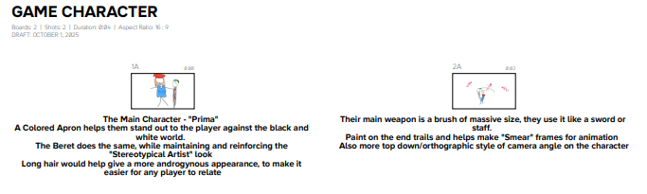

Tetra (Main Antagonist) –
Backstory: A painter gone rogue, looking to unseal the forbidden colors
Personality: Rough and brash, they are unapologetic about the wrongs they commits, and act quite rude consistently
Appearance: TBD
Abilities: Similar to and mirroring the Main Character.
Relevance to the Story: Main Antagonist
Relationship to Other Characters: Main Character – They are annoyed with the main character and upset that she continues to foil their plans.

Artificial Intelligence Use in Opponent and Enemies: There will be multiple enemy types, each with their own AI making them act different ways. A ranged enemy might run away from the player to line up shots, while a melee enemy tracks and runs towards the player.
Non-combat and Friendly Characters: A shopkeeper would be the main one interacted with during gameplay. If a village is added, NPCs would show up for very minor roles.

Levels:
Training Level: An introductory level, where the player helps save a village from an attack of grunt enemies, this allows the player to start the tutorial and learn as they beat the enemies.
For Each Level:
Synopsis: Each level are different dungeons, imprisoning scary bosses.
Introductory Material: Given by the antagonist at the end of the last level, and start of the current.
Objectives: Clear rooms and beat a boss at the end
Details: TBD
MAP: TBD Level Design still yet to be complete
Critical Path: Procedurally Generated
Important and Incidental Encounters: Each level has one shop somewhere randomly inside, and a boss at the end.

Interface:
HUD: A display on the bottom of the screen as GUI shows the players current color, as well as the build up for their ranged attack ability.
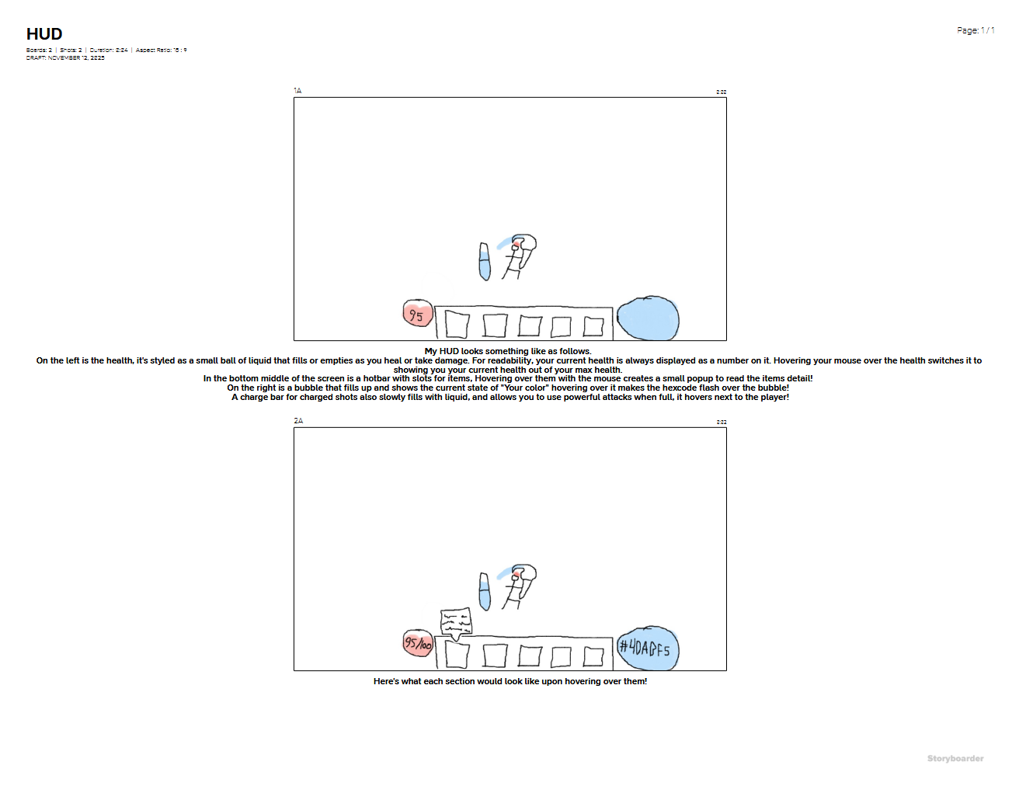
Menus: A start menu that includes the normal story and likely a “daily challenge” mode. Also an in-game options menu, with usual visual, audio, and control settings.
Camera model: Top Down
Control System: Mouse and Keyboard. WASD to move, Left Click to Attack. The player attacks in the direction they’re moving, they cannot “aim” with the mouse. Except for the right click ranged option, which is aimed with the mouse. Holding down right click shows the aiming reticle and then letting go fires the shot. The player can also do a roll with spacebar which gives them immunity for a short duration. For item pickups, there is one interact button to pick up any items, as well as talk to NPCs, open doors, and buy laid out shop items. There are two other buttons specifically for picking up colors, one to add and one to subtract. All three of these “Interactive” buttons should be easy for the player to reach. Like Q to Subtract, E to Add, and F to interact.
Audio, Music, Sound Effects: Very "wet" bombastic design, many sound effects based on sounds of painting (Paint splashing, rollers rolling, sounds of brush on canvas.) Cartoonish.
Music specifically should be plucky and upbeat. The Player should feel like a hero.
Intended Style: Black and white “sketched” style for the backgrounds and world. A very “painted” look for the enemies. Both Watercolor and Oil Paint, depending on the enemy type.

Elevator Pitch:
What color are you? Art is about self-expression. This is its simplest form. Can you express "you" in just one color? This concept is explored in my game PaintRush! In this storybook world trouble is brewing, a villain seeks to destroy it all, and someone needs to stop them. That's why it is up to you; taking the place of a young artist, to paint and splatter your way through the evils plaguing the land. PaintRush! is a top-down hack and slash roguelike, where you beat enemies to collect both random items and random colors to gain strength. These colors you collect are used in PaintRush!'s main mechanic, the mixing system, to add or subtract from "your color" to provide you buffs and allow you to truly customize your build as you see fit. Can you find your color, and use it to save the world?

Game Design Pillars:

Table of Game Design Pillar Chart
Pillar | Definition | Example | Your Game Concept
Plot | The actual storyline of the game stripped down to what happens. | Bioshock’s twist ending | An evil artist seeks to free an ancient evil. The Player must stop them.
Character | The aspect that fleshes out characters, giving them personality and making them relatable. | Kratos’ relationship with his son in God of War (2028) | The main character is an artist, an important job, and they carry much responsibility on their shoulders.
Lore | Everything that makes the game world feel vibrant and alive, existing beyond the main characters and plot. | The item descriptions in Dark Souls | Certain structures being rendered in color, alluding to the people who created them in the past.

My primary focus in this game is the plot. Although simple, that’s what this story is meant to be, and the player should enjoy playing through it.

The Lore will enhance the plot by adding areas for it to take place in, and add stakes as the whole world is in trouble.
The Characters will enhance the plot by being present in it. The plot involves the main character because of who they are and what they can do. It acts as the catalyst for the player to interact with the main plot.

Lore is almost entirely made up of and reinforced by visuals. This is especially important with this games theme and focus. But the color choice especially, and the where to choose to use it, will add a lot of detail to the lore.
The Mechanics will help reinforce the character and plot by making the player feel like a hero. They are meant to be special in this world, and as such the player should feel it while they fight hordes of enemies. They are meant to feel strong and unique.

Marketing Plan:

1. Game Overview
Title: PaintRush!
Genre: Action Roguelike
Platforms: PC
Target Audience: All Ages
Unique Selling Points: Unique Visuals, Custom “Mixing” mechanic

2. Market Research
Competitive Analysis:
Key Competitor: Hades
Strengths and Weaknesses of Competitors:
Strengths: Compelling gameplay, Witty and charming dialogue.
Weaknesses: Difficulty, Player Choice vs RNG for build variation.
Opportunities for differentiation: More focus on build variation and gameplay for all ages and skill ratings.

Industry Trends:
Player Preferences and Market Shifts: Roguelike is a massive genre, continuing to grow, with lots of competitors but a very high player count. Plus replay ability being a major factor of the genre keeps fans entertained for a long time.

Player Personas:
Ideal Player?: Someone who enjoys creativity and experimenting with game mechanics
What motivates them to play your game?: A focus on player agency in build diversity. A custom mechanic that allows players to play as they wish while also allowing RNG to not make every game the exact same.

3. Branding and Messaging
Game Logo and Visual Identity: Bright Colors, and a colorable Logo. Painted style is the main visual
Tagline/Slogan: “What’s your color?”
Key Themes and Emotional Appeal: Self Discovery and Confidence. Personal Expression
Brand Voice and Tone: Uplifting and Inspiring Reflection

4. Marketing Strategy
Teaser Trailers and Announcements: Trailers showcasing gameplay as well as mechanics. Keep to short snippets on Social Medias.
Social Media Presence: Small snippets of gameplay as the game counts down to release.
Website and Landing Page: Keep a website with a standalone download of the game, as well as marketing the game/showing off mechanics.
Press And Influencer Outreach: Look for influencers who play games in the genre. It’s a game that could be played multiple times, as such it makes for good daily content to keep a channel active.
Community Engagement: None during development. No early access release. Maybe a fanart contest to keep theme with the game. Level Concept Art Contest and NPC, perhaps winner gets their design added to the game?
Crowdfunding or Early Access Plans: None. Crowdfunding seems too volatile to get into or rely upon.

5. Launch
Game Launch Trailer: About a month from release put out one definitive trailer
Press Releases and Media Coverage: Stick to Social Medias and Influencers
Influencer and Streamer Partnerships: Send some influencers free copies for review
Paid Advertising: Minimal, no Google or Web ads. For online ads, advertise through influencers to those that are already interested in similar games. Otherwise, maybe run a TV ad to target parents who might buy for children.
Giveaways and Contests: Art Contest pre-launch. Maybe a set seed “Daily Run” ingame where players can see how far they get/ how fast.

6. Monetization Strategy
Pricing Model: Pay Once, about 20$
In-Game Purchases and Microtransactions: None, avoid doing so
Partnerships and Sponsors: Send free copies to some influencers for review, but no ongoing sponsorships
Reviews and Feedback: Steam Reviews after release

7. Conclusion
Next Steps and Long Term Vision: Possibility for Sequel depending on player reaction.

SWOT Analysis:

Strengths:
-Replayability
-Player Choice
-RNG to stop games for being too repetitive

Weaknesses:
-RNG might stop player agency
-Too Simple of a story/ “Made for kids”
-Hard to balance difficulty for all ages, younger crowd and game playing veterans

Opportunities:
-Roguelike is a growing genre, and a fan favorite
-Very unique for it’s approach on the genre

Threats:
-Many entrenched series create sequels often, brand recognition is huge in the space
-Massive Genre means many competitiors

How can you use Strengths to take advantage of the opportunities presented?
Replayability should help keep players who try the game or who are used to others in the genre.

How can you overcome the Weaknesses that prevent you from taking advantage of these opportunites.
Curve RNG to player choice, or allow them to have some effect on the pool(?) (Testing needed)

How can you use your strengths to reduce the impact of the threats?
The focus on Player Choice is unique to the genre while keeping main staples players expect, should help set it apart from competitors

What plan can you create to address your weaknesses and minimize potential threats?
Perhaps an extra “Challenge” mode for more veteran players, or expanded difficulty options

